**Tags:**

* If you have a large playbook, it may become useful to be able to run only a specific part of it rather than running everything in the playbook. Ansible supports a “tags:” attribute for this reason.
* Tags can be applied to many structures in Ansible (see “tag inheritance”, below), but its simplest use is with individual tasks. Here is an example that tags two tasks with different tags:
* If there are 10 tasks in our yml file and we want to execute only two out of them. Then we can use tags as below

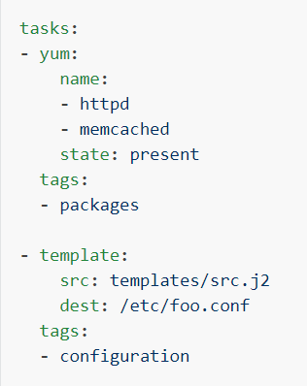

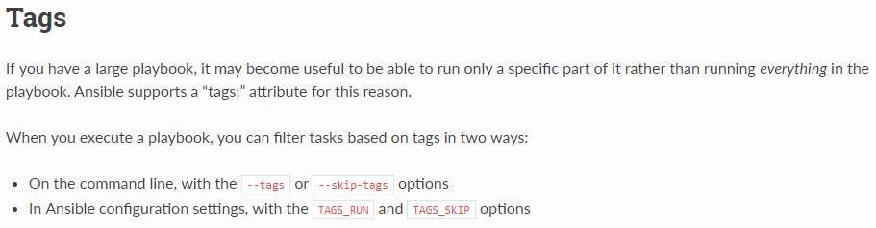

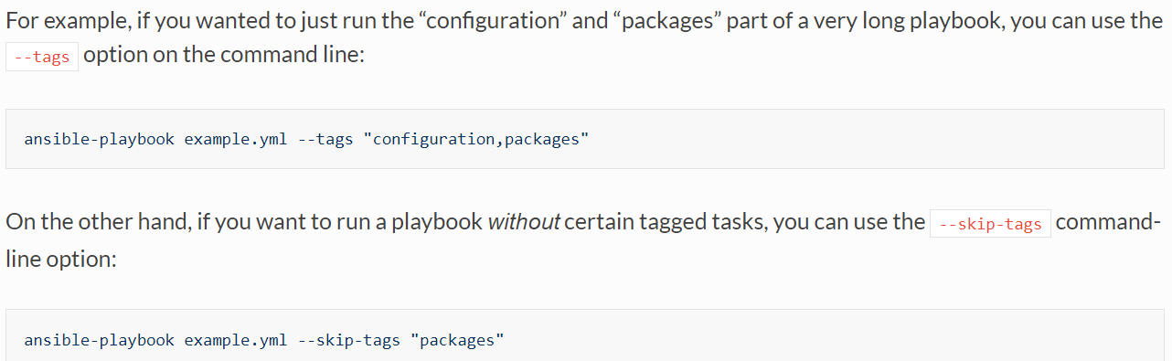

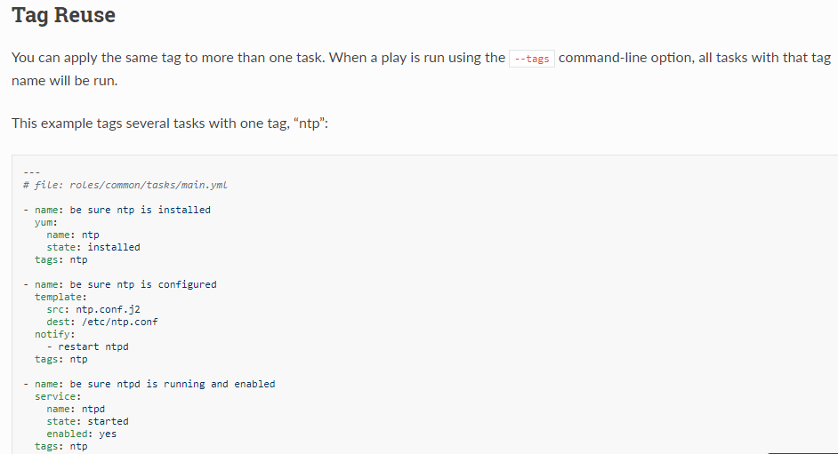

* These are old methods. Now roles are better than these

**About .retry file:**

* When Ansible has problems running plays against a host, it will output the name of the host into a file in the user's home directory ending in '.retry'. These are often not used and just cause clutter

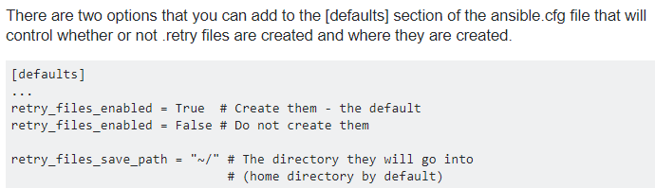

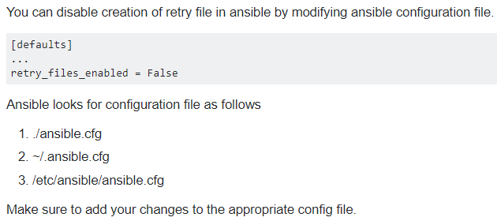

* We can change the config file and hosts file location. But we need to run the playbook from config file location if it’s not default location
* For hosts file, we can use -i if it is in another location